Activity 12-5: Sampling Senators (cont.)

We would like to take many random samples of senators, but this is very slow and tedious to do. We will use an Applet to do the work for us.
Open Internet Explorer and navigate to the following address:
http://www.rossmanchance.com/applets/senators/samplesenators.html

Initially the applet displays the distribution of the lengths of service, the proportions of Republicans and Democrats, and Males and Females in the entire Senate. For now, remove the check next to Show Gender.
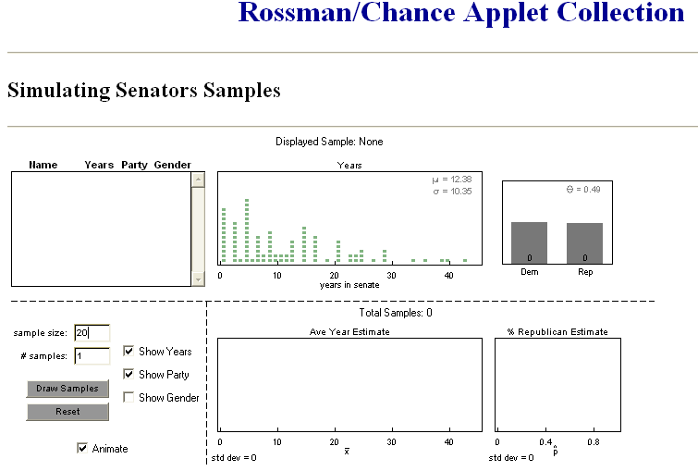

Let’s begin by selecting a sample of size 20 (change the sample size to 20) and click Draw Samples.

The box in the upper left corner of the applet displays the 20 senators in your random sample, and their characteristics (you may need to scroll up in the box to see all 20 senators). Summaries of the years of service and the party breakdowns of the sample are also given in the next 2 boxes.

In the first column of the table below, record the sample proportion of Republicans in your sample and the sample mean years of service of the senators in your sample.

- Click the Draw Samples button again. The applet will select a second random sample of 20 senators. Again, record the sample proportion of Republicans in this sample and the sample mean years of service. Do this for a total of 10 samples. Record the results for each sample in the table below.

Sample | 1 | 2 | 3 | 4 | 5 | 6 | 7 | 8 | 9 | 10
Proportion Republicans
Mean years

- Did you get the same sample proportion of Republicans in each of your ten samples? Did you get the same sample mean years of service in each of your ten samples?

These elementary questions illustrate a very important statistical property known as sampling variability. The value of sample quantities varies from sample to sample. This simple idea is actually a very important and powerful one, which lays the foundation for most techniques of statistical inference.

(c) Create a dotplot of the sample mean years you found. Also include ten more sample means from the list on the board:

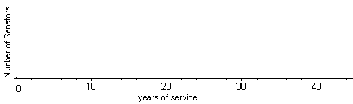

- Compare this distribution to that obtained in (f) of Activity 12-4. Do these sample means seem to be centered roughly at the population mean of 12.38 as they were with a sample size of 5 Senators?

- Which of the two distributions (sample size 5 or sample size 20) has less variability in the values of the sample mean years of service?

- In which case (sample size 5 or sample size 20) is the result of a single sample more likely to be close to the truth about the population?

The precision of a sample statistic refers to its variability from sample to sample. Precision is related to sample size: Sample means and sample proportions from larger samples are more precise/closer together than those from smaller samples. Since these statistics are also unbiased, those from larger samples provide a more accurate estimate of the corresponding population parameter.

Two caveats are in order, however. First, one still gets the occasional “unlucky” sample whose results are not close to the population even with large sample sizes. Second, the sample size means little if the sampling method is not random. Remember that the Literary Digest had a huge sample of 2.4 million, yet their results were not close to the truth about the population.

