Part I

- A company wanted to determine the health care costs of its employees. A sample of 25 employees were interviewed and their medical expenses for the previous year were determined. Later the company discovered that the highest medical expense in the sample was mistakenly recorded as 10 times the actual amount. However, after correcting the error, the corrected amount was still greater than or equal to any other medical expense in the sample. Which of the following sample statistics must have remained the same after the correction was made?
  - Range
  - Mean
  - Median
  - Mode
  - Variance

- Gina’s doctor told her that the standardized score (z-score) for her systolic blood pressure as compared to the blood pressure of other women her age, is 1.50. Which of the following is the best way to interpret this standardized score?
  - Gina’s systolic blood pressure is 150.
  - Gina’s systolic blood pressure is 1.50 standard deviations above the average systolic blood pressure of women her age.
  - Gina’s systolic blood pressure is 1.50 above the average systolic blood pressure of women her age
  - Gina’s systolic blood pressure is 1.50 times the average systolic blood pressure for women her age
  - Only 1.5% of women Gina’s age have a higher systolic blood pressure than she does.

- When describing the Null Hypothesis we may say each of the following except:
  - The null hypothesis is the statement of no difference
  - We may fail to reject the null hypothesis if the data is somewhat close to the hypothesized value.
  - We may accept the null hypothesis if the sample obtained is close to the hypothesized value.
  - The null hypothesis is the value that we assume to be true for the sake of the research.
  - Assuming the null hypothesis to be true yields the p-value or probability that the data obtained occurred by chance.

- The probability that the Red River will flood in any given year has been estimated from 200 years of historical data to be one in four. This means:
  - The Red River will flood every four year.
  - In the next 100 years, the Red River will flood exactly 25 times.
  - In the last 100 years, the Red River flooded exactly 25 times.
  - In the next 100 years, the Red River will flood about 25 times.
  - In the next 100 years, it is very likely that the Red River will flood exactly 25 times.

- At a college the scores on the chemistry final exam are approximately normally distributed, with a mean of 75 and a standard deviation of 12. The scores on the calculus final are also approximately normally distributed, with a mean of 80 and a standard deviation of 8. A student scored 81 on the chemistry final and 84 on the calculus final. Relative to the students in each respective class, in which subject did this student do better?
  - There is no basis for comparison, since the subjects are different from each other and are in different departments.
  - The student did better in chemistry.
  - The student did better in calculus.
  - The student did equally well in each course.
  - There is not enough information for comparison, because the number of students in each class is not known.

- The heights of adult women are approximately normally distributed about a mean of 65 inches with a standard deviation of 2 inches. If Rachael is at the 95th percentile in height for adult women, then her height, in inches, is closest to
  - 61
  - 63
  - 65
  - 67
  - 69

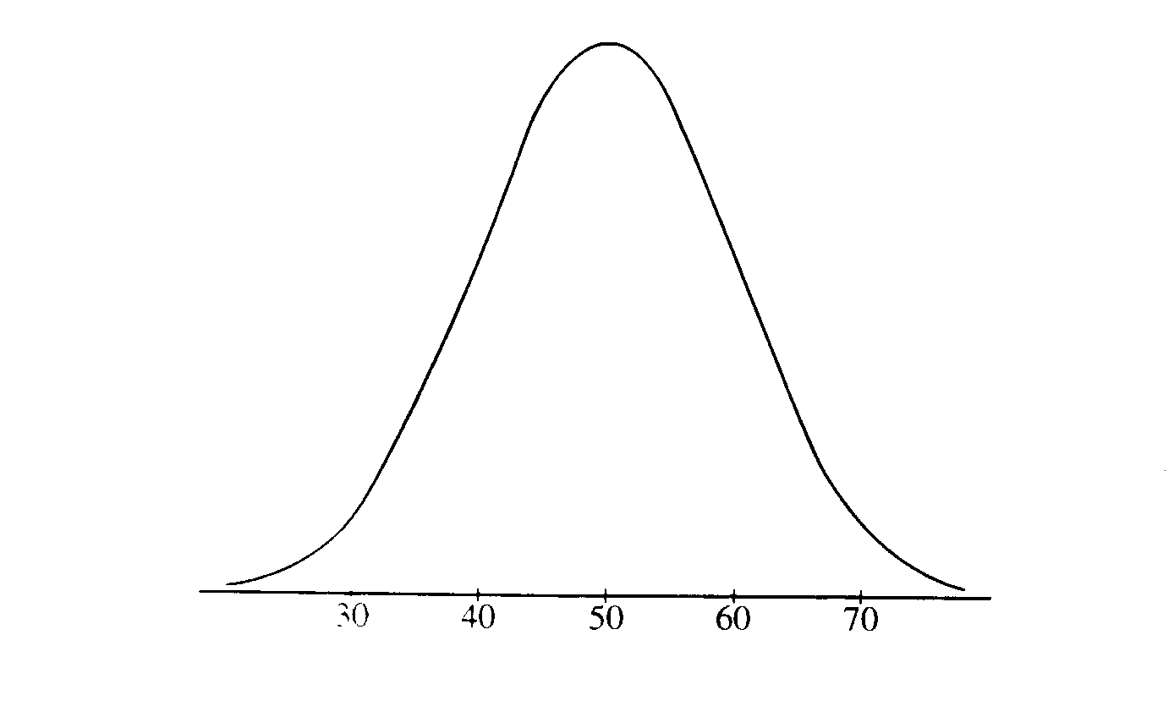
- Which of the following is the best estimate of the standard deviation of the distribution shown in figure above?
  - 5
  - 10
  - 30
  - 50
  - 60

- Which of the following is the best estimate of the mean of the distribution shown in figure above?
  - 10
  - 30
  - 40
  - 50
  - 65
- The back-to-back stem-and-leaf plot below gives the percentage of students who dropped out of school at each of the 49 high schools in a large metropolitan school district.
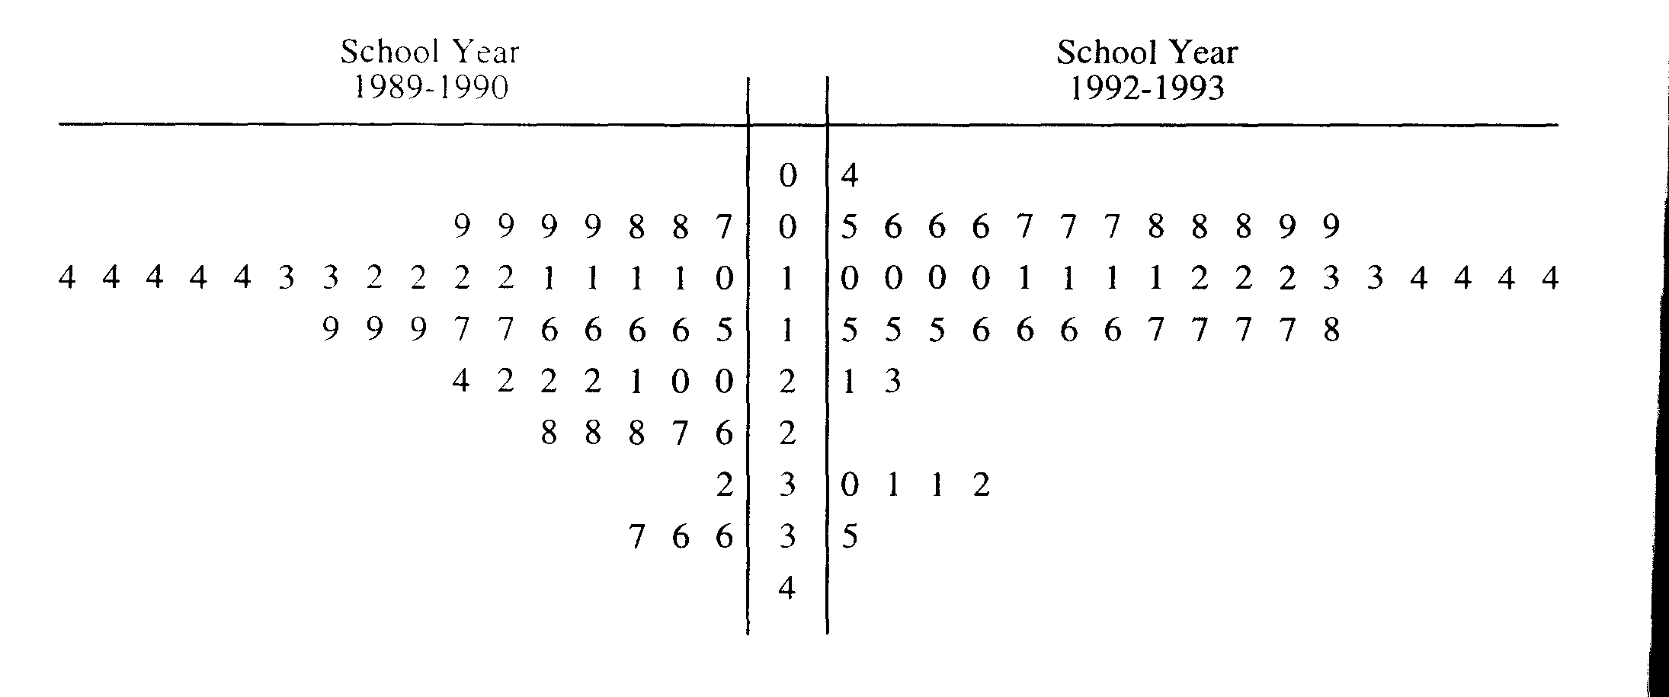
For 1992-1993, 1 | 2 represents 12%.
Which of the following is NOT justified by these data?
  - The drop-out rate decreased in each of the 49 high schools between the 1989-1990 and 1992-1993 school years.
  - For the school years shown. most students in the 49 high schools did not drop out of high school
  - In general, drop-out rates decreased between the 1989-1990 and 1992-1993 school years.
  - The median drop-out rate of the 49 high schools decreased between the 1989-1990 and 1992-1993 school years.
  - The spread between the schools with the lowest drop-out rates and those with the highest drop-out rates did not change much between the 1989-1990 and 1992-1993 school years.

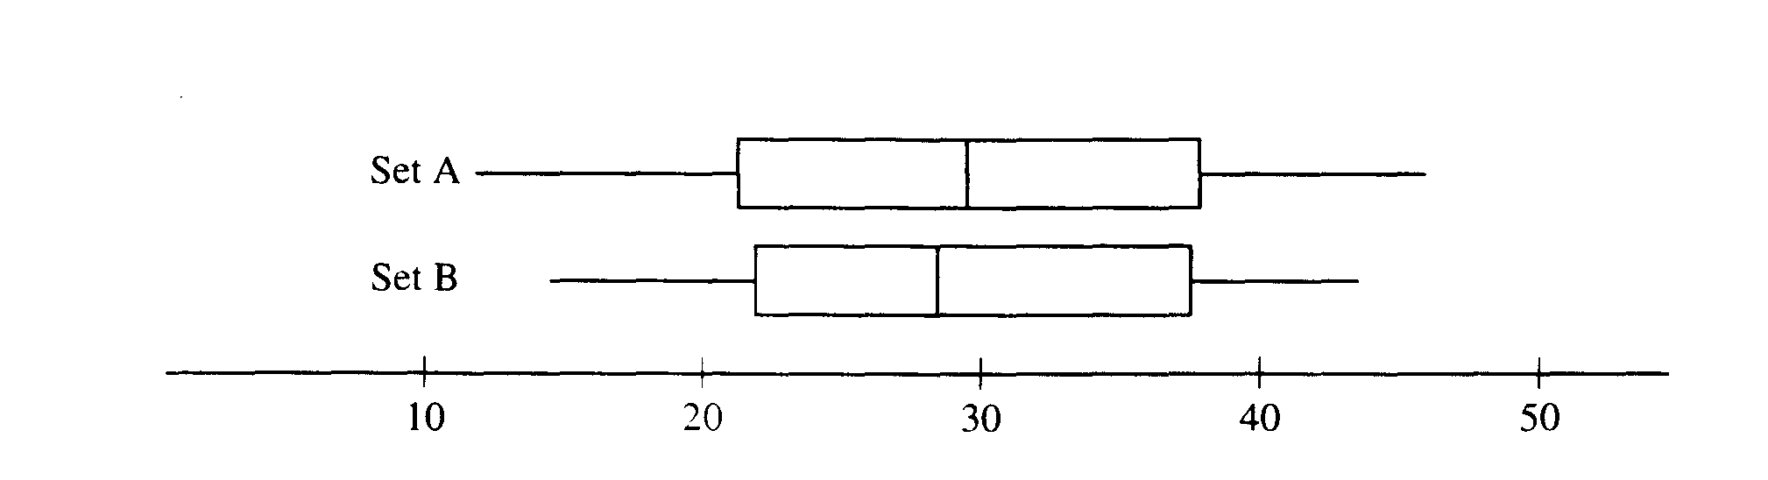
- The boxplots above summarize two data sets. A and B. Which of the following must be true?
I. Set A contains more data than Set B.
II. The box of Set A contains more data than the box of Set B.
III. The data in Set A have a larger range than the data in Set B.
  - I only
  - III only
  - I and II only
  - II and III only
  - I. II. and III

- The student government at a high school wants to conduct a survey of student opinion. It wants to begin with a simple random sample of 60 students. Which of the following survey methods will produce a convenience sample?
  - Survey the first 60 students to arrive at school in the morning.
  - Survey every 10th student entering the school library until 60 students are surveyed.
  - Use random numbers to choose 15 each of first-year, second-year, third-year, and fourth-year students.
  - Number the cafeteria seats. Use a table of random numbers to choose seats and interview the students until 60 have been interviewed.
  - Number the students in the official school roster. Use a table of random numbers to choose 60 students from this roster for the survey.

- Suppose we give a test in which scores do not follow a normal distribution. I want to take samples from these. What is the least number of tests we need to sample in order to use the Central Limit Theorem?
  - 10
  - 30
  - 60
  - Any number of times since the original distribution is not normal.
  - No way to use the Central Limit Theorem on quantitative data.

- Suppose you toss a fair coin. The probability that a head lands up is ¹/₂. In order to use the Central Limit Theorem on the distribution of sample proportions what is the least number of tosses you would have to have?
  - 10
  - 20
  - 30
  - Any number of times since the original distribution is uniform.
  - No way to use the Central Limit Theorem on categorical binary data.

- Which of the following can be used to show a cause-and-effect relationship between two variables?
  - A census
  - A controlled experiment
  - An observational study
  - A sample survey
  - A cross-sectional survey

- Given the 95% confidence interval of the proportion of all voters that will vote for Alfred E. Newman is (.45, .56), which statement is valid:
  - “95% of all voters have a probability of between (.45 and .56) of voting for Alfred E. Newman”
  - “The true proportion of all voters that will vote for Alfred E. Newman in the election is in the interval (.45, .56) 95% of the time”
  - “We are 95% confident The true proportion of all voters that will vote for Alfred E. Newman in the election is in the interval (.45, .56)”
  - “The probability that the true proportion of all voters that will vote for Alfred E. Newman in the election is in the interval (.45, .56) is approximately 95%”
  - All of the above are valid statements

- The term margin of error refers to
  - The half-width of the confidence interval
  - The distance we had and subtract from the central value (mean or proportion) to give us a confidence interval
  - The critical standard score (Z* or t*) times the standard error
  - All of the above refer to the Margin of error
  - None of the above

- Which of the following will reduce the size of a confidence interval (if p-hat remains the same):
  - Increase the confidence level
  - Decrease confidence level
  - Decrease the sample size
  - Increase the sample size
  - Both b and d will have the affect of decreasing the confidence interval.

- There is a linear relationship between the number of chirps made by the striped ground cricket and the air temperature. A least squares fit of some data collected by a biologist gives the model

$\hat{y}$=25.2+3.3x 9<x<25
where x is the number of chirps per minute and is the estimated temperature in degrees Fahrenheit. What is the estimated increase in temperature that corresponds to an increase of 5 chirps per minute?
  - 3.3° F
  - 16.5° F
  - 25.2° F
  - 28.5° F
  - 41.7° F
- To check the effect of cold temperature on the elasticity of two brands of rubber bands, one box of Brand A and one box of Brand B rubber bands are tested. Ten bands from the Brand A box are placed in a freezer for two hours and ten bands from the Brand B box are kept at room temperature. The amount of stretch before breakage is measured on each rubber band, and the mean for the cold bands is compared to the mean for the others. Is this a good experimental design?
  - No, because the means are not proper statistics for comparison.
  - No, because more than two brands should be used.
  - No, because more temperatures should be used.
  - No, because temperature is confounded with brand.
  - Yes

 | Job | No Job | Total
Juniors | 13 | 5 | 18
Seniors | 13 | 26 | 39
Total | 26 | 31 | 57

- A survey of 57 students was conducted to determine whether or not they held jobs outside of school. The two-way table above shows the numbers of students by employment status (job, no job) and class (juniors, seniors. What proportion of Students that do not have a job are seniors?
  - ⁵/₃₁
  - ²⁶/₃₁
  - ²⁶/₃₉
  - ²⁶/₅₇
  - None of the above

- The symbol r is used to represent ____________.
  - Correlation Coefficient
  - Proportion of variability
  - Coefficient of determination
  - Standard Deviation of the Slope
  - None of the above

- If a bivariate set of data has an r = -.5, which of the following is true
  - The slope of the regression line goes up going from left to right.
  - There is a very strong association.
  - The proportion of variability is .71.
  - We can claim causation exists between these two variables
  - None of the above

- If a bivariate set of data has an R2 = .95, which of the following must be true
  - The regression line has a positive slope
  - There exists a strong association between these two variables
  - r is approximately .975
  - a, b and c are all must be true.
- A sample of 2500 cases are drawn at random. The standard deviation is 20. What is the standard error of the mean (or in other words, the standard deviation of the sampling distribution)?
  - ²/₂₅
  - ²/₅
  - ¹/₅
  - ⁴/₂₅
  - 20

- Which of the following would describe the resistance of linear regressions:
  - Very resistant
  - Somewhat resistant
  - Very little resistance

- Given that a distribution is normal with a mean 23 and a standard deviation of 6, the area under the curve to the left of the value 27 is closest to :
  - .333
  - .5
  - .67
  - .75
  - .9

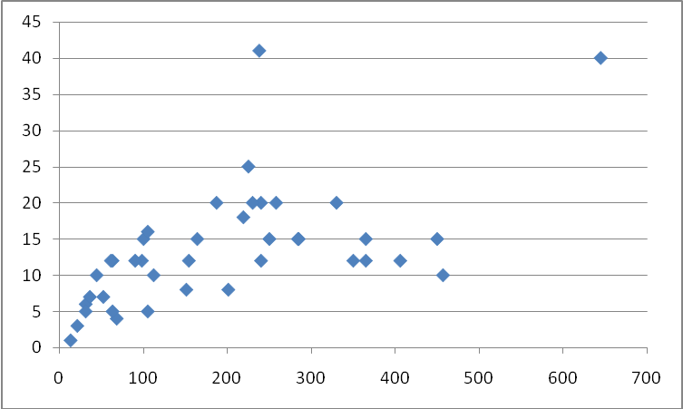
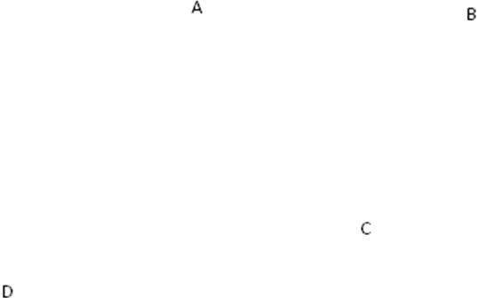
- Which point in the accompanying diagram at right would be considered an outlier
  - A
  - B
  - C
  - D

- Which point in the accompanying diagram at right would be considered influential
  - A
  - B
  - C
  - D

1. I have had HS Stats classes mass 100 Peppermint Patties from a bulk package. Two sets of these are stored in a file on my web site. (PPMsWeights2009.MTW): The data is in grams. In 2005 The package of Peppermint patties indicated that the mass of three bars is 36g, therefore each patty is 12g., while in 2009 the package indicated the mass of three bars to be 41 or 13.67g per patty.
- Are the technical conditions satisfied to use the Central Limit Theorem (explain)?

- Estimate the true average mass of a peppermint patty using a confidence of 90% for the 2009 sample. What does this mean (write a sentence).

- You want to use a hypothesis test to show at a significance level of .05 that the true mean weight of all Peppermint Patties in 2009 is more than the advertised weight.

- Define the parameter of interest and state the null and alternative hypotheses for This problem (Words and symbols):

__: _____________________________________________

H₀: ________: ______________________________________________________________________

H_{A}:________: ______________________________________________________________________

- Are technical conditions satisfied to use the CLT.

- What is the Test statistic and p-value:

- Your conclusion statistical and in context.

2. A Gallup Poll conducted December 11-14, 2003. Of the 1011 randomly selected adults aged 18 and older, 455 said they had too little time for relaxing or doing nothing.

- Are the technical conditions satisfied to use the Central Limit Theorem (explain)?

- Estimate the true proportion of adults that feel they do not have enough to do nothing or relax at a confidence of 99%. What does this mean (write a sentence)? Show work for partial credit.

You want to use a hypothesis test to show at a significance level of .01 that the true proportion people feeling they do not have any time is to relax or do nothing is not equal to 50%
.
- Define the parameter of interest and state the null and alternative hypotheses for This problem (Words and symbols):

H₀: _______:________________________________________________________________________

H_{A}:_______:________________________________________________________________________

- Are technical conditions satisfied to use the CLT.

- What is the alpha and critical Z for this problem?

- What is the Test statistic (Show work for partial credit):

- What is your conclusion, statistical and in context?
3. The gestation period and the longevity of life for several different animals were recorded. The mean, standard deviation and correlation coefficient between these two variables are shown below.

 | Gestation | Longevity | r
Mean | 194.675 | 13.55 | 0.589313
std dev | 145.376 | 8.283286 | 0.589313

Recall that
Suppose you wanted to predict the Gestation period for an animal based on its longevity of life.

- Which variable is explanatory, which is response?

- What is the slope of the regression line?

- What is the y- intercept of the regression line?

- What is the regression equation for predicting the gestation period from the longevity points?

- What percent of the variation of gestation may be attributed to longevity score?

- What does the y-intercept mean in terms of the problem?

- What does the slope of the regression line mean in terms of the problem?

4. The following Scatterplot and data came from an experiment a previous student did relating length of a pendulum vs. the time it takes the pendulum to complete a swing (Length vs. Period) for the pendulum experiment.
Pendulum
Length | # of Swings
33.5 | 16
20 | 20
57.5 | 12
12 | 25
32 | 15
45 | 13
24 | 18
27.5 | 17
10 | 27
50 | 13

  - Draw a line through the best fit line through this data.
  - Using Minitab or your calculator find the following
r² = ___________________
r = ___________________
Regression Equation: ___________________________________
  - Create a scatterplot below of what you would expect the residual plot to look like for this data

  - Explain briefly Why a transformation necessary.

